**Module 1:**

**Effective Communication Task:**

Write professional emails based on any 5 of the following scenarios. Ensure clarity, conciseness, and a formal tone.

1. **Thank you Email**

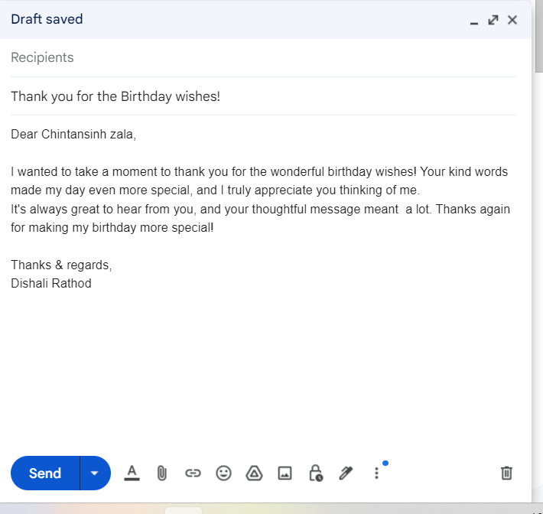

**3. Reminder Email**

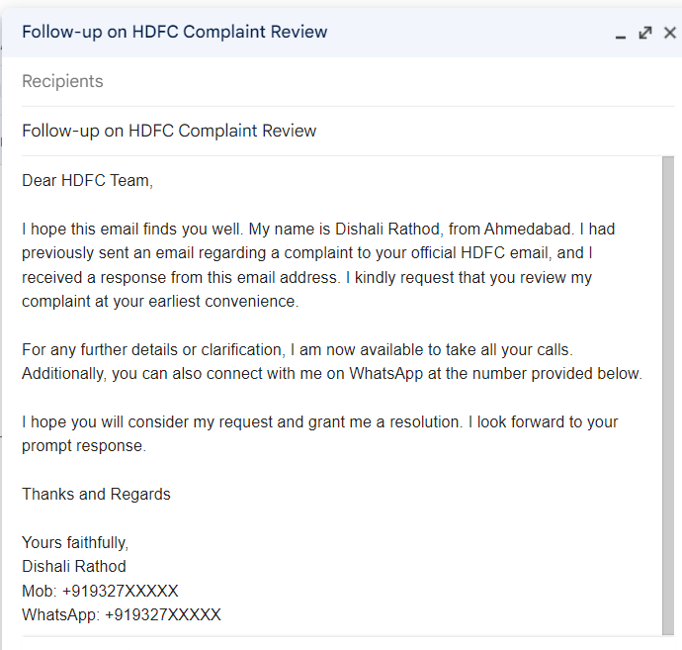

**5. Email of Inquiry for Requesting Information**

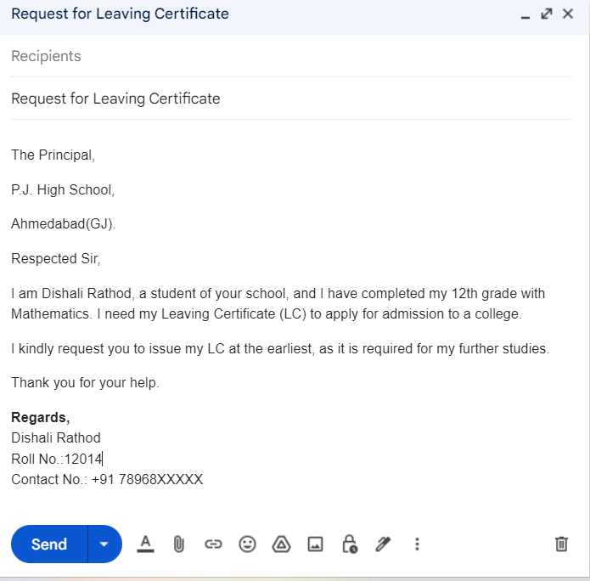

**9. Resignation Email**

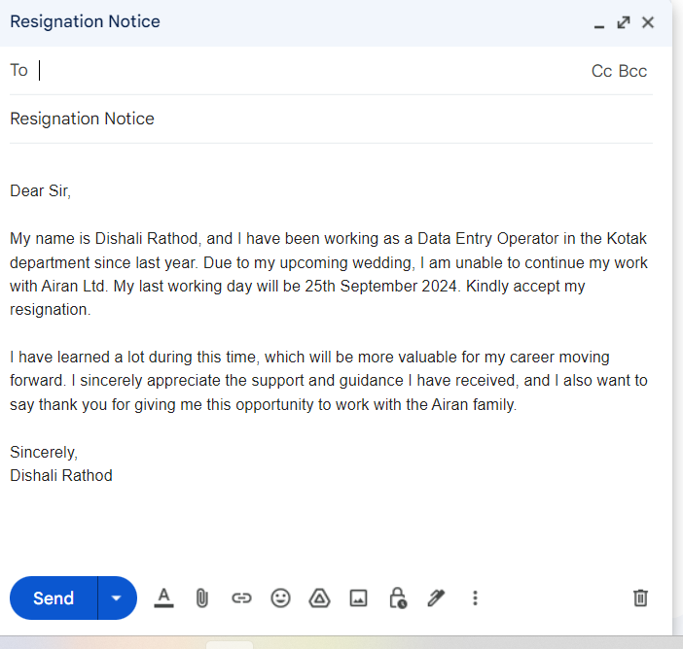

**10. Introduction Email to Client**

**Subject**: Promote your business online with SEO, SMM, and Creative Design

Dear Sonia,

I hope you're doing well! I specialize in helping businesses like your business grow through **SEO**, **Social Media Marketing (SMM)**, **social media management**, and **creative poster design**.

Here’s how I can assist you:

* **SEO**: Improve your website's search rankings.
* **SMM**: Run targeted ad campaigns for more leads.
* **Social Media Management**: Boost engagement with quality content.
* **Creative Designs**: Creative designs that capture attention and boost engagement.

If you’re interested in growing your business online, I’d love to discuss how we can work together. Let me know if we can set up a quick chat!

Best regards,  
Dishali Rathod  
Contact: +91 932763XXXXX